Nama : Ziyan Fadilla Saporette

NIM : 18090058

Kelas : 5A

PRAKTIKUM 1

1. Source Code

Kenalan.php -> application/controller

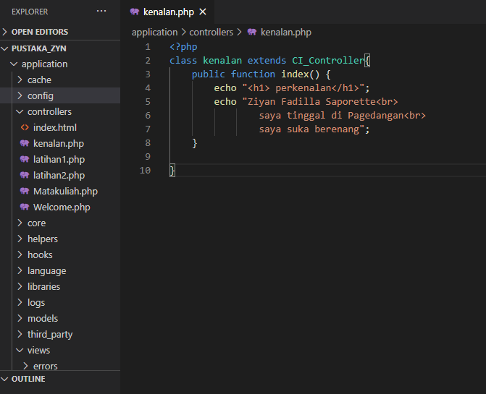

1. URL

<http://localhost:8090/pustaka_zyn/index.php/kenalan>

1. Capture Hasil

